|  |  |
| --- | --- |
| Student name: Thinh Le | Date: 2024-11-12 |

**PROJECT SUMMARY**

# Norovirus statistics and graphs

## Which primary mode has the highest number of Norovirus outbreaks?

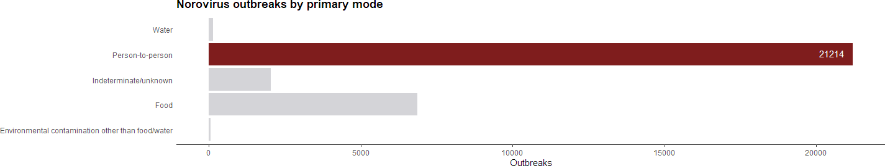

Figure - Norovirus outbreaks by primary mode

Result: *Person-to-person* is the main reason of Norovirus outbreaks, with 21214 cases.

## Where are the top 3 places that Norovirus outbreaks occur most frequently when the primary mode is Person-to-person?

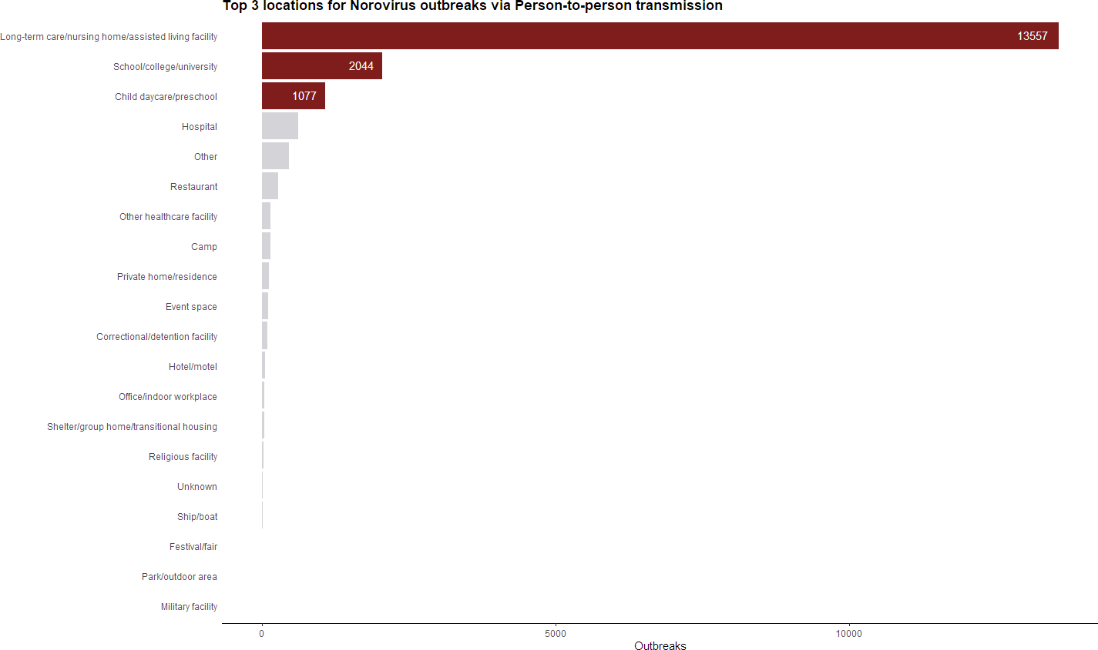

Figure – Top 3 locations for Norovirus outbreaks via Person-to-person transmission

Result: Top 3 places that easily transmit the Norovirus are *Child daycare/preschool*, *Hospital*, and *Long-term care/nursing home/assisted living facility*, with 1077, 2044 and 13557 cases, respectively.

# Escherichia statistics and graphs

## Which primary mode has the highest number of Norovirus outbreaks?

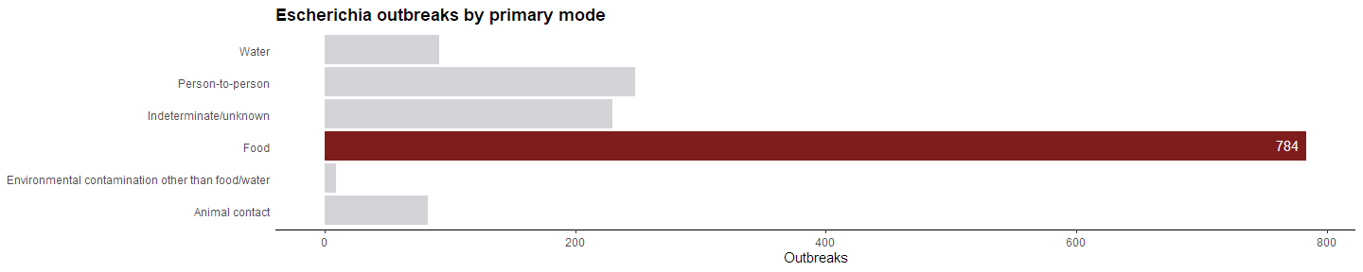

Figure – Escherichia outbreaks by primary mode

Result: *Food* is the main reason of Escherichia outbreaks, with 784 cases.

## Which food vehicle is the most frequently associated with Escherichia outbreaks when the primary mode is Food?

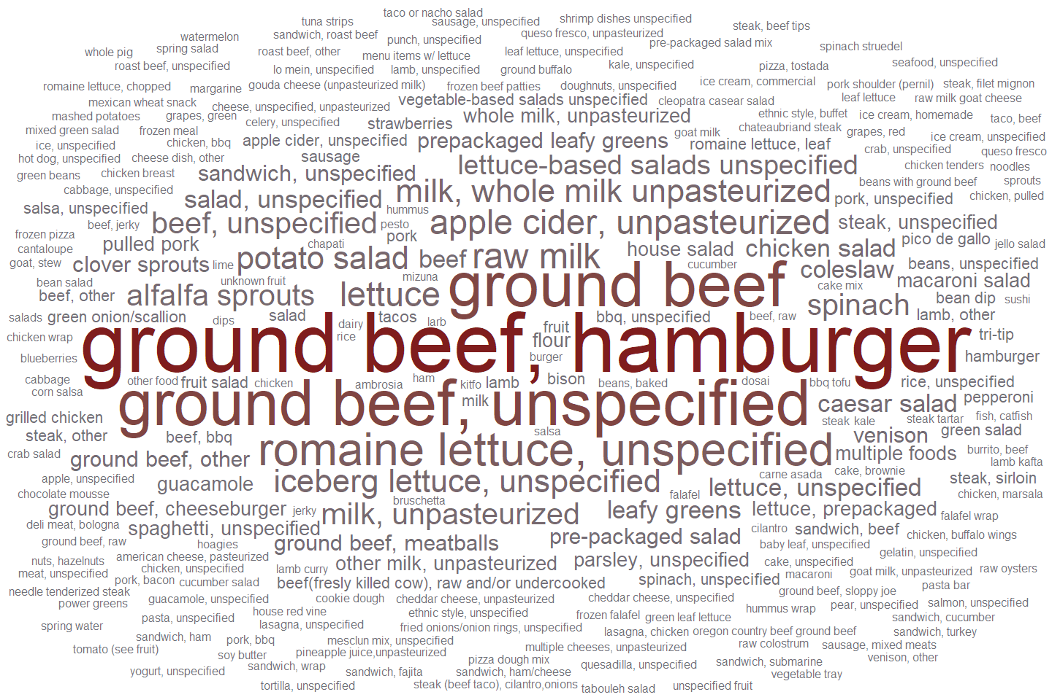

Figure – Frequency of food vehicles associated with Escherichia outbreaks through food transmission

Result: *ground beef, hamburger* is the most frequently associated with Escherichia outbreaks when the primary mode is Food.

# Select at least one statistic and present a graph showing both Escherichia and Norovirus together

## The total number of sickened (illnesses, hospitalizations & deaths) of Norovirus and Escherichia etiologies by year

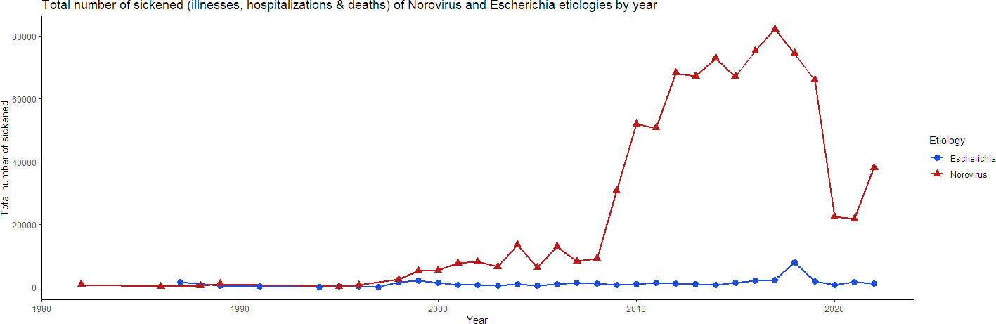

Result: Norovirus has a higher number of sickened individuals compared to Escherichia throughout the years.

## Norovirus and Escherichia etiologies outbreaks by state

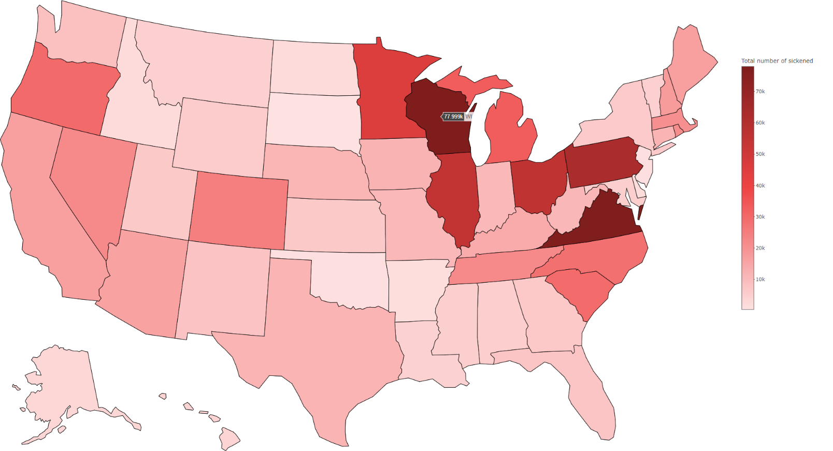

Figure 5 – Norovirus etiologies outbreaks by state

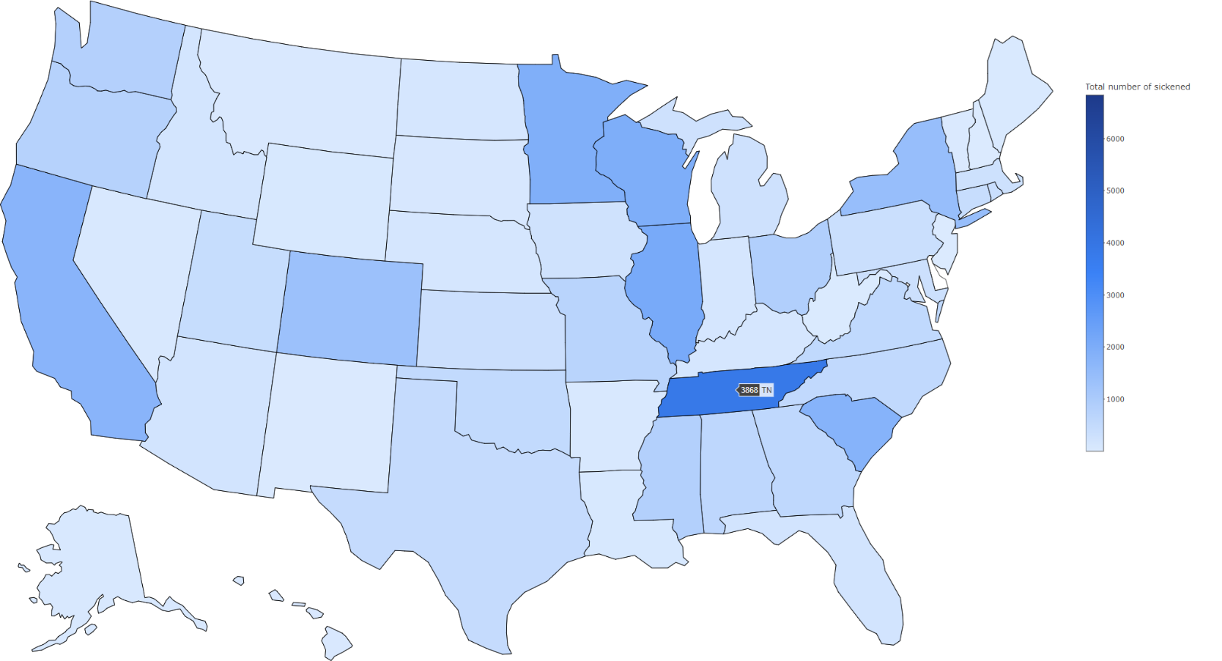

Figure 6 – Escherichia etiologies outbreaks by state

Result: Norovirus cases are concentrated in Wisconsin, while Escherichia cases are more frequent in Tennessee.